Secure Coding Lab – 11

Dasari Mohan Amritesh

18BCN7038

Download and install visual studio (recent edition)

Write a C++ code of your own to build an executable and run the same.

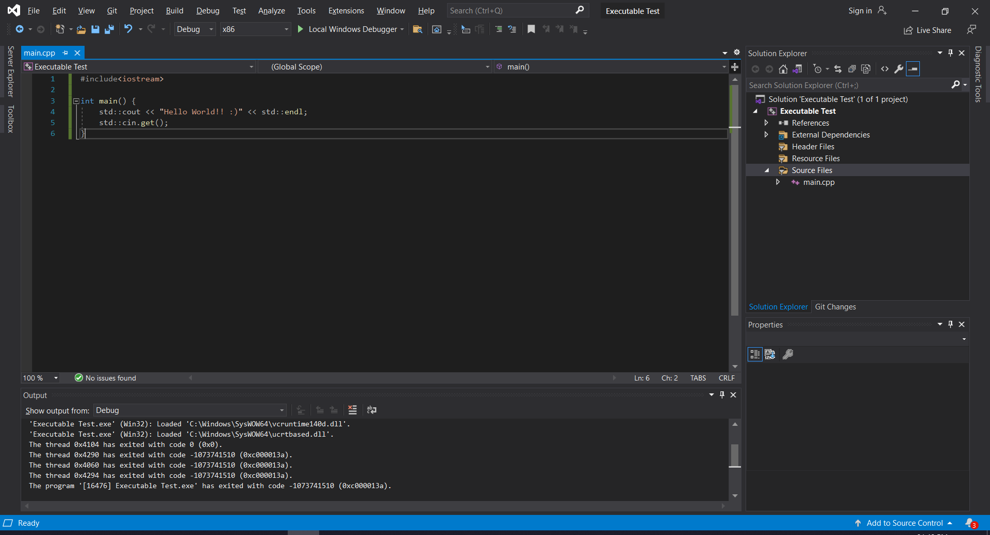

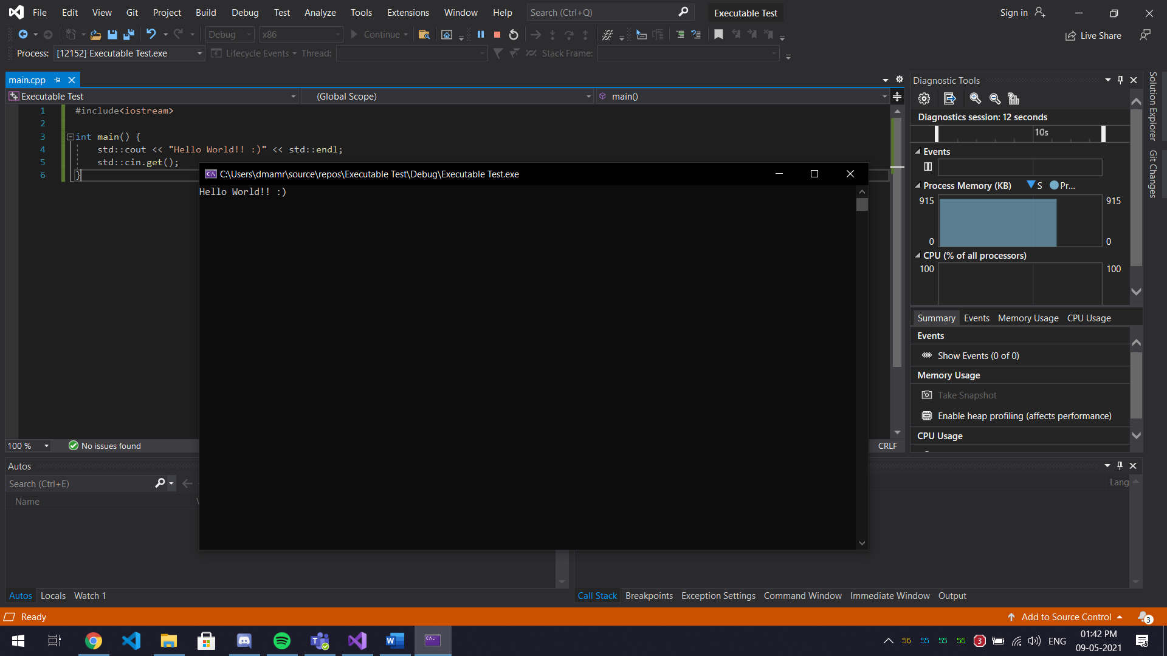

Download process explorer and verify the DEP & ASLR status

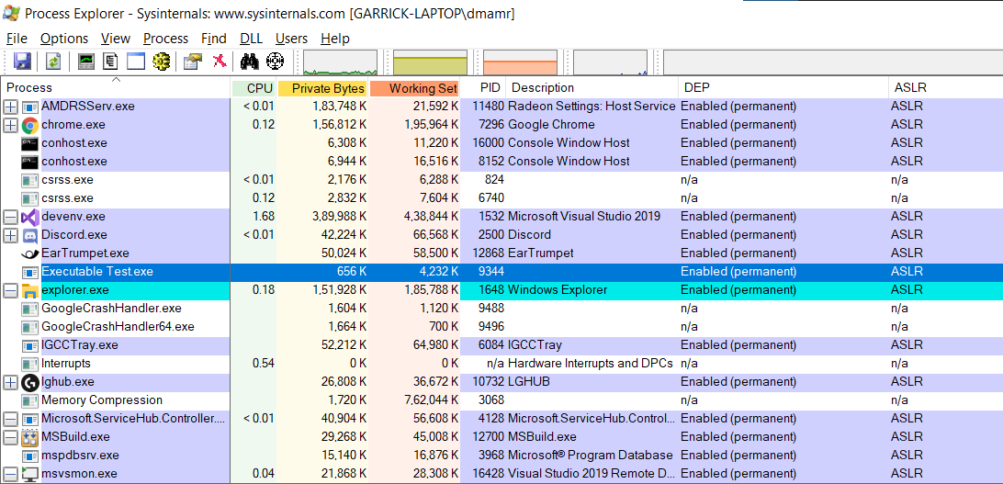

Disable software DEP, ASLR and SEH in the visual studio and rebuild the same executable

Project > properties > configuration properties > linker

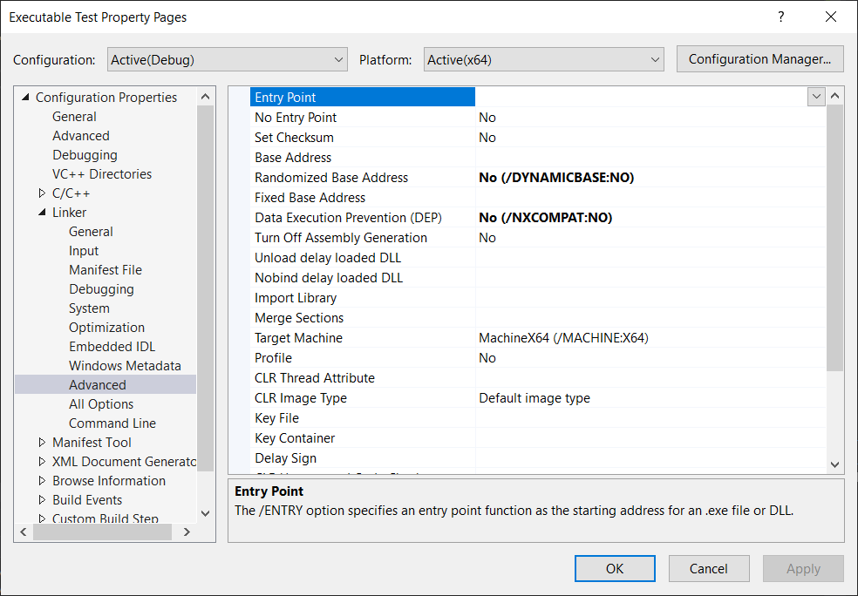



By Default, in project properties, DEP and ASLR properties are enabled and even upon disabling them, DEP is still in affect